**Animation with HTML5**

1 Download zip file “week3-files” ., unzip and put all files in your folder for week 3.

Use file example_move.html as a start point. If you click on green square it will move right and stop. Open it using Dreamweaver or Notepad++, to see code behind.

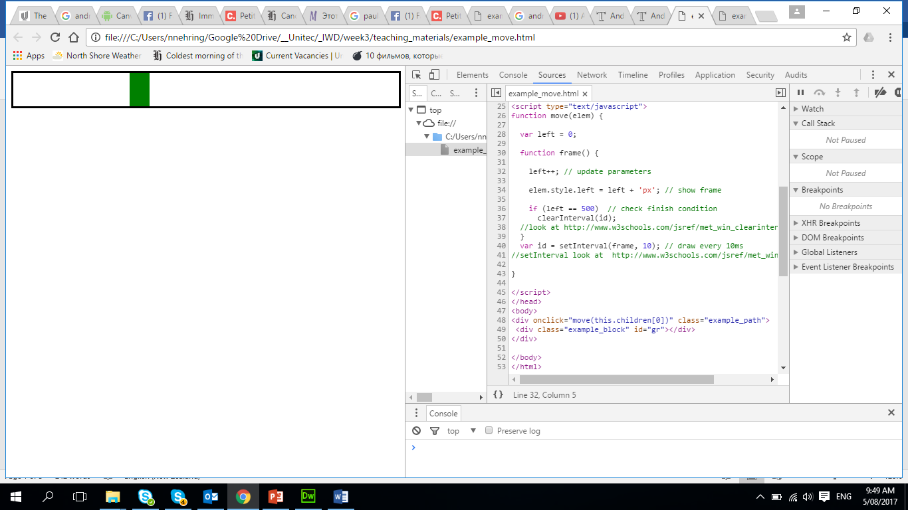

2 If we need to find an error in the code we need to use debugger. (please use Chrome for JavaScript)

In the Chrome, right click/ inspect element/Source. You need to put break points and you can add Watch expresions. As all debuggger have it has **step over(F10)**, **step in(F11)**, **step out(Shift+F11)**,. Please test it how it is work.

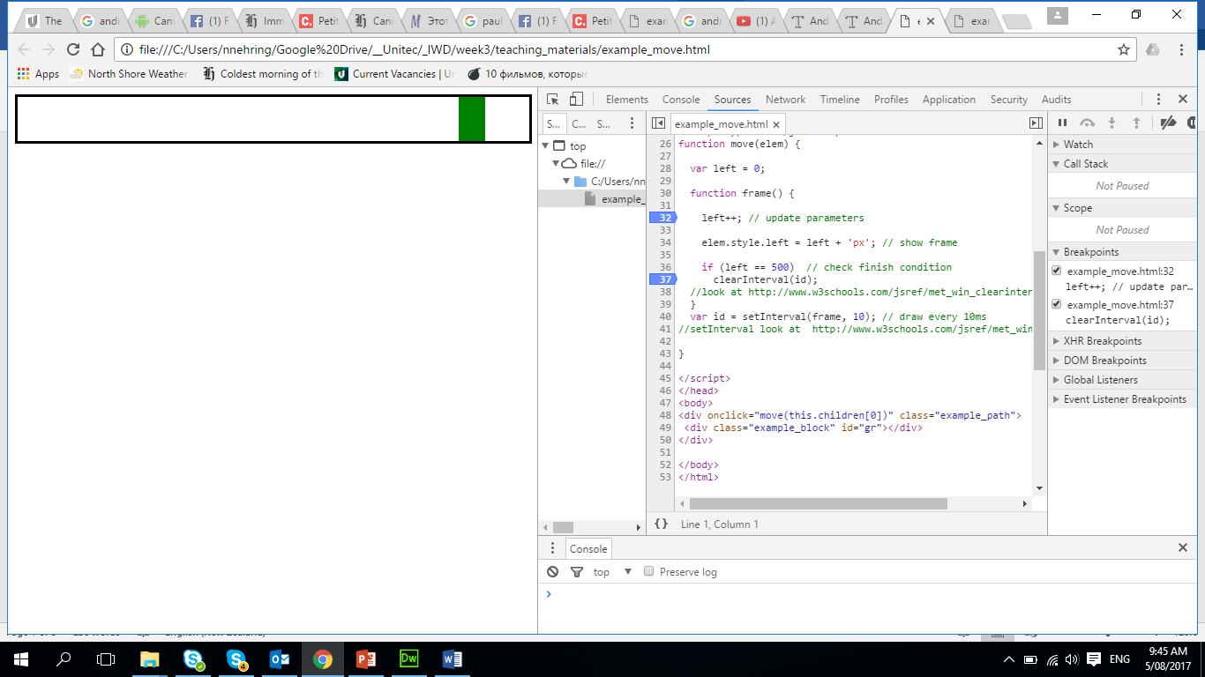

3 Please change code for a **move** function ( add variable point, and check conditions), after changing code test it and if you find any errors you need to fix and test that your code is working.

|  |  |
| --- | --- |
| if left <30 - stop | if left >300 - change direction |

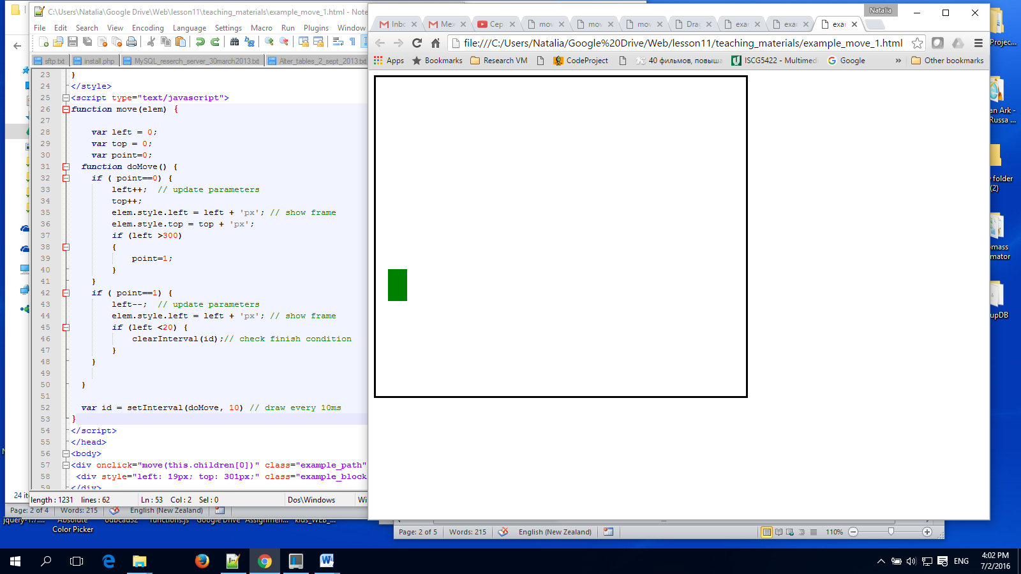

4 Please do other change code for the **move** function ( we add extra path)

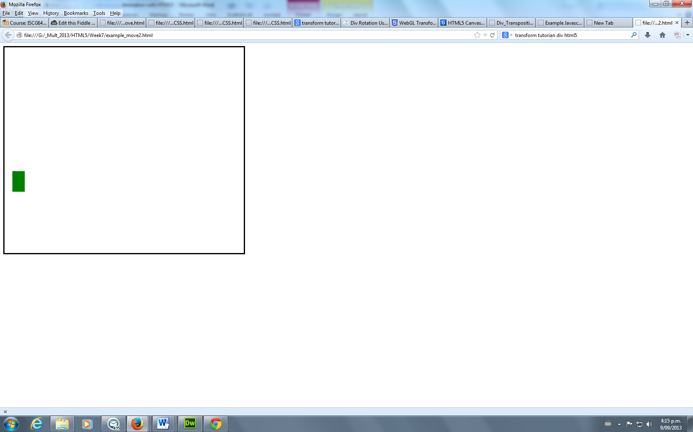

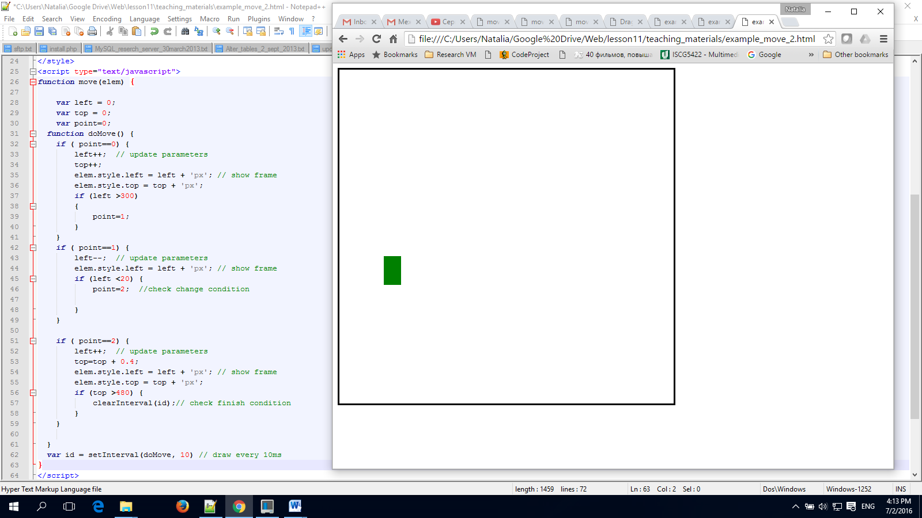

5 Change “style” for the green block put background – “butterfly.gif” and for the “example_path” put image “flowers-daizy.JPG (background-repeat:no-repeat;) 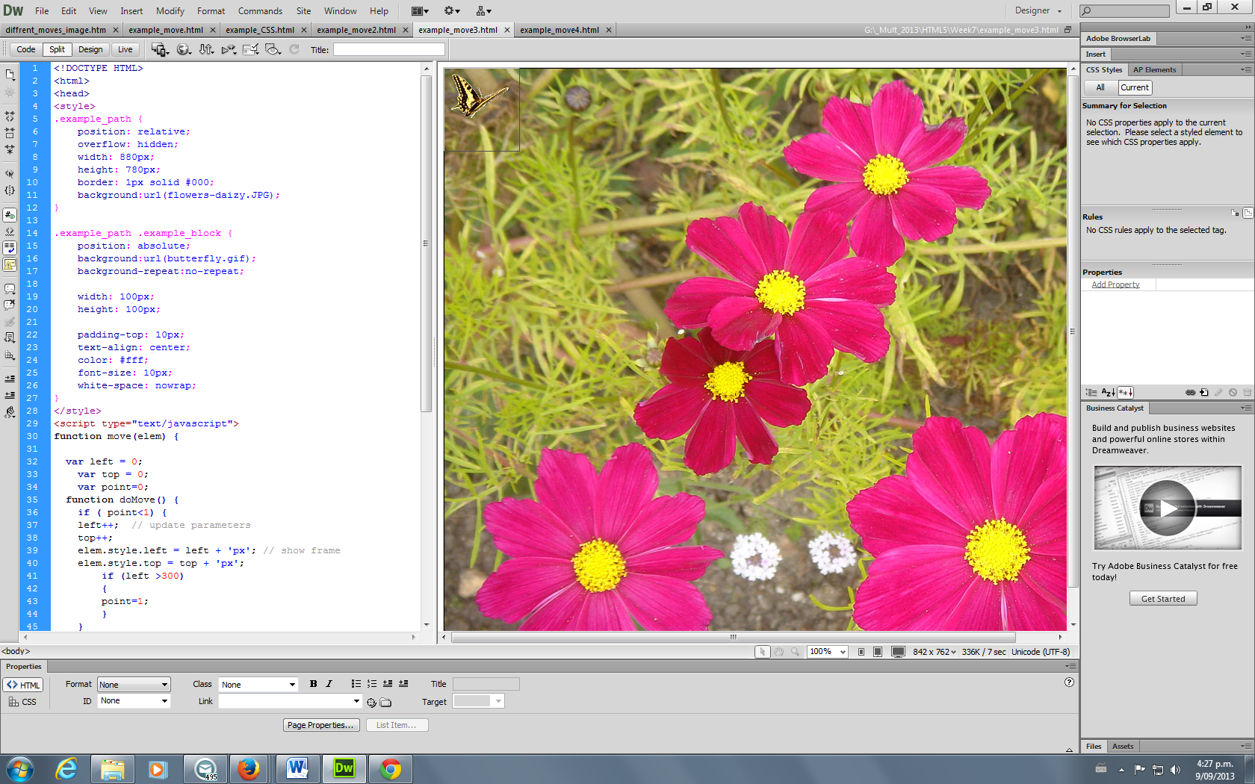

5 We add music – audio control ( inside <body> tag). Please test it.

<audio controls>

<source src="swan_lake.mp3" type="audio/mpeg">

Your browser does not support the audio element.

</audio>

We change our movement on more complex one:

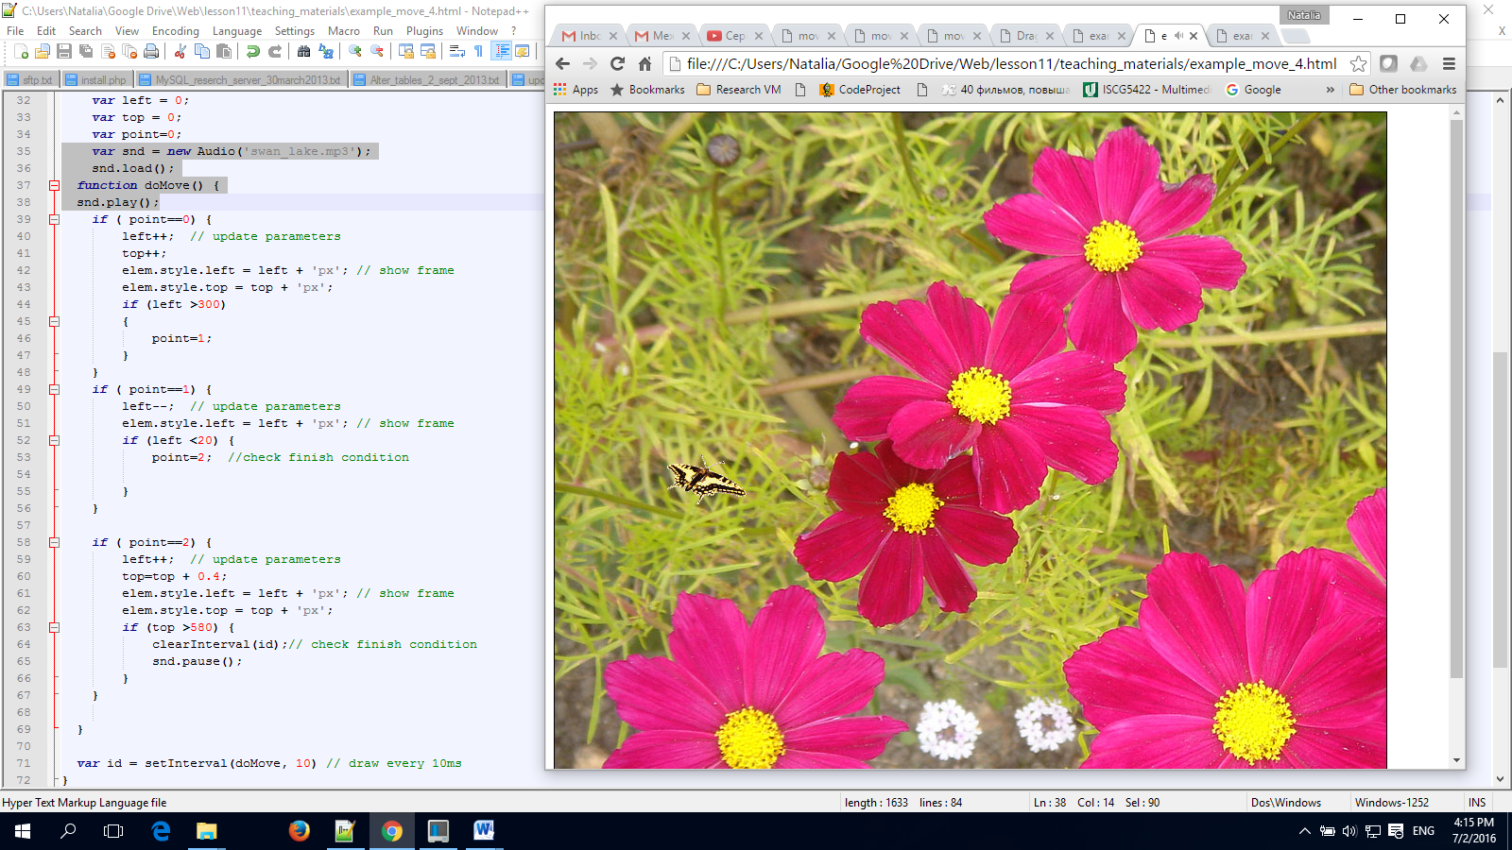

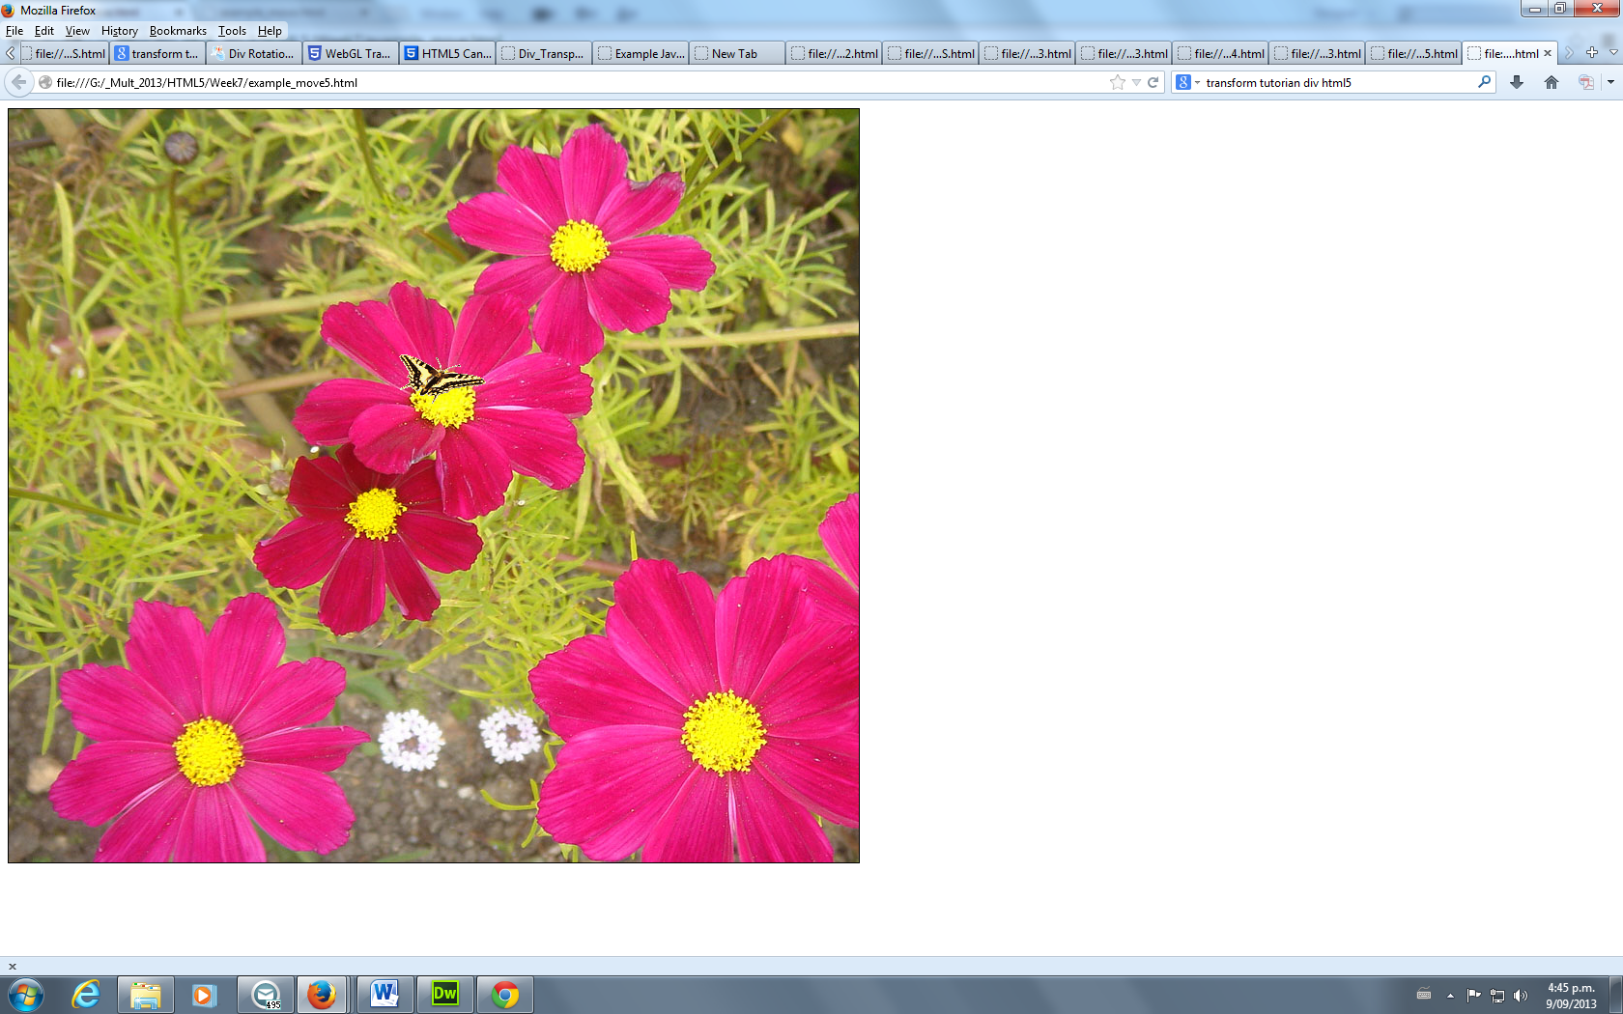

Point=2

Point=1

6 We want now to play music then “butterfly” start move.

Declare variable:

var snd = new Audio('swan_lake.mp3');

snd.load(); // you need to have it, that it will play on mobile device.

In function - function doMove() add line: snd.play();

And then movement stop add : snd.pause(); // to pause music.

7 It is possible to express same logic using switch statement from JavaScript:

